One of the most important concepts in object-oriented programming is that of inheritance. Inheritance allows us to define a class in terms of another class, which makes it easier to create and maintain an application. This also provides an opportunity to reuse the code functionality and fast implementation time.

When creating a class, instead of writing completely new data members and member functions, the programmer can designate that the new class should inherit the members of an existing class. This existing class is called the **base** class, and the new class is referred to as the **derived** class.

The idea of inheritance implements the **is a** relationship. For example, mammal IS-A animal, dog IS-A mammal hence dog IS-A animal as well and so on.

**Base & Derived Classes:**

A class can be derived from more than one classes, which means it can inherit data and functions from multiple base classes. To define a derived class, we use a class derivation list to specify the base class(es). A class derivation list names one or more base classes and has the form:

class derived-class: access-specifier base-class

Where access-specifier is one of **public, protected,** or **private**, and base-class is the name of a previously defined class. If the access-specifier is not used, then it is private by default.

Consider a base class **Shape** and its derived class **Rectangle** as follows:

#include <iostream>

using namespace std;

// Base class

class Shape

{

public:

void setWidth(int w)

{

width = w;

}

void setHeight(int h)

{

height = h;

}

protected:

int width;

int height;

};

// Derived class

class Rectangle: public Shape

{

public:

int getArea()

{

return (width * height);

}

};

int main(void)

{

Rectangle Rect;

Rect.setWidth(5);

Rect.setHeight(7);

// Print the area of the object.

cout << "Total area: " << Rect.getArea() << endl;

return 0;

}

When the above code is compiled and executed, it produces the following result:

Total area: 35

**Access Control and Inheritance:**

A derived class can access all the non-private members of its base class. Thus base-class members that should not be accessible to the member functions of derived classes should be declared private in the base class.

We can summarize the different access types according to who can access them in the following way:

|  |  |  |  |
| --- | --- | --- | --- |
| **Access** | **public** | **protected** | **private** |
| Same class | yes | yes | yes |
| Derived classes | yes | yes | no |
| Outside classes | yes | no | no |

A derived class inherits all base class methods with the following exceptions:

* Constructors, destructors and copy constructors of the base class.
* Overloaded operators of the base class.
* The friend functions of the base class.

**Type of Inheritance:**

When deriving a class from a base class, the base class may be inherited through **public, protected** or **private** inheritance. The type of inheritance is specified by the access-specifier as explained above.

We hardly use **protected** or **private** inheritance, but **public** inheritance is commonly used. While using different type of inheritance, following rules are applied:

* **Public Inheritance:** When deriving a class from a **public** base class, **public** members of the base class become **public** members of the derived class and **protected** members of the base class become **protected** members of the derived class. A base class's **private** members are never accessible directly from a derived class, but can be accessed through calls to the **public** and **protected** members of the base class.
* **Protected Inheritance:** When deriving from a **protected** base class, **public** and **protected** members of the base class become **protected** members of the derived class.
* **Private Inheritance:** When deriving from a **private** base class, **public** and **protected** members of the base class become **private** members of the derived class.

**Multiple Inheritances:**

A C++ class can inherit members from more than one class and here is the extended syntax:

class derived-class: access baseA, access baseB....

Where access is one of **public, protected,** or **private** and would be given for every base class and they will be separated by comma as shown above. Let us try the following example:

#include <iostream>

using namespace std;

// Base class Shape

class Shape

{

public:

void setWidth(int w)

{

width = w;

}

void setHeight(int h)

{

height = h;

}

protected:

int width;

int height;

};

// Base class PaintCost

class PaintCost

{

public:

int getCost(int area)

{

return area * 70;

}

};

// Derived class

class Rectangle: public Shape, public PaintCost

{

public:

int getArea()

{

return (width * height);

}

};

int main(void)

{

Rectangle Rect;

int area;

Rect.setWidth(5);

Rect.setHeight(7);

area = Rect.getArea();

// Print the area of the object.

cout << "Total area: " << Rect.getArea() << endl;

// Print the total cost of painting

cout << "Total paint cost: $" << Rect.getCost(area) << endl;

return 0;

}

When the above code is compiled and executed, it produces the following result:

Total area: 35

Total paint cost: $2450

Inheritance those are provided by C++ are as followings:

1.                Single Inheritance

2.                Multilevel Inheritance

3.                Multiple Inheritance

4.                Hierarchical Inheritance

5.                Hybrid Inheritance

In Inheritance Upper Class whose code we are actually inheriting is known as the Base or Super Class and Class which uses the Code are known as Derived or Sub Class.

1)      In **Single Inheritance** there is only one Super Class and Only one Sub Class Means they have one to one Communication between them

[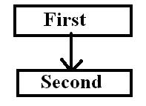](http://ecomputernotes.com/images/Single_Inheritance.jpg)

2)      In **Multilevel Inheritance** a Derived class can also inherited by another class Means in this Whena Derived Class again will be inherited by another Class then it creates a Multiple Levels.

[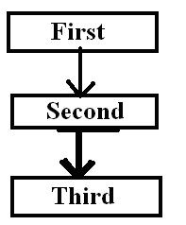](http://ecomputernotes.com/images/Multilevel_Inheritance.jpg)

3)       **Multiple Inheritances** is that in which a Class inherits the features from two Base Classes When a Derived Class takes Features from two Base Classes.

[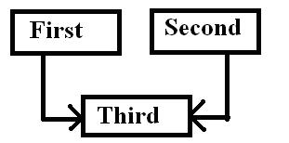](http://ecomputernotes.com/images/Multiple_Inheritances.jpg)

4)       **Hierarchical Inheritance** is that in which a Base Class has Many Sub Classes or When a Base Class is used or inherited by many Sub Classes.

[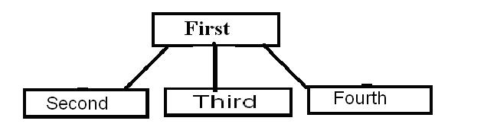](http://ecomputernotes.com/images/Hierarchical_Inheritance.jpg)

5)      **Hybrid Inheritance: -** This is a Mixture of two or More Inheritance and in this Inheritance a Code May Contains two or Three types of inheritance in Single Code.

[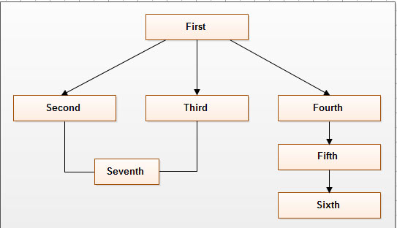](http://ecomputernotes.com/images/Hybrid_Inheritance.jpg)